**✈️📄 AIRLINE RESERVATION SYSTEM — FINAL PROJECT REPORT**

**✅ Title**

**Mini Project: Airline Reservation System Using MySQL**

**✅ Objective**

The objective of this project is to **design and implement an Airline Reservation System** using **MySQL Workbench** that can:

* Manage flights, customers, bookings, and seats,
* Maintain data integrity with foreign keys,
* Automate updates using triggers,
* Provide useful queries and views for easy reporting.

**✅ Tools Used**

* **Database:** MySQL
* **IDE:** MySQL Workbench
* **Language:** SQL (DDL, DML, Views, Triggers)

**✅ Steps Followed**

1️⃣ **Schema Design**

* Designed tables: **Airports**, **Aircrafts**, **Flights**, **Customers**, **Bookings**, **Seats**.
* Applied primary and foreign keys to normalize data.

2️⃣ **Data Insertion**

* Inserted realistic sample data for airports, aircrafts, flights, customers, and bookings.

3️⃣ **Constraints**

* Set unique IATA codes for airports.
* Used foreign keys to maintain relationships between flights, seats, customers, and bookings.

4️⃣ **Triggers**

* AfterBookingInsert to mark seats as booked automatically.
* AfterBookingCancel to free seats when a booking is cancelled.

5️⃣ **Views**

* Created AvailableSeats view to show all free seats.

6️⃣ **Reports/Queries**

* Query to find available seats.
* Query to search flights by route/date.
* Booking summary report with customer and flight details.

**✅ Screenshots & Results**

**📌 1.**Seats**Table — Sample Data**

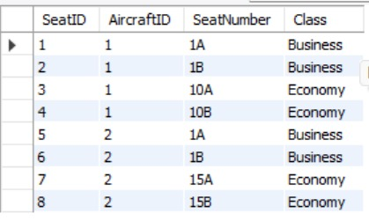

**📌 2. Available Seats Query**

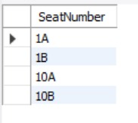

**📌 3. Flight Search by Route/Date**

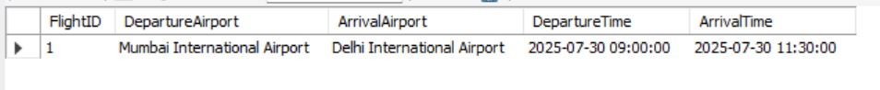

**📌 4. Booking Summary Report**

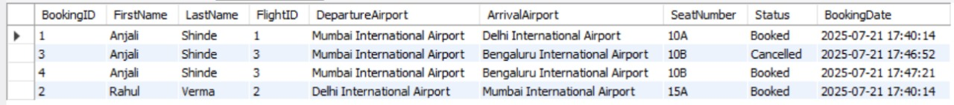

**📌 5. Triggers Created**

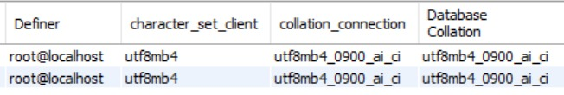

**✅ Conclusion**

The **Airline Reservation System** was successfully designed and implemented.  
It demonstrates a normalized relational schema with real constraints, data integrity, automation using triggers, and simple yet practical reporting using SQL queries and views.  
This shows a clear understanding of SQL concepts, good design practice, and practical usage for a real-world scenario.

**✅ Submitted By**

**Name:**  *ANJALI SHINDE*  
**Semester:** *3RD YEAR 1ST SEM*  
**Date:** *21-07-2025*